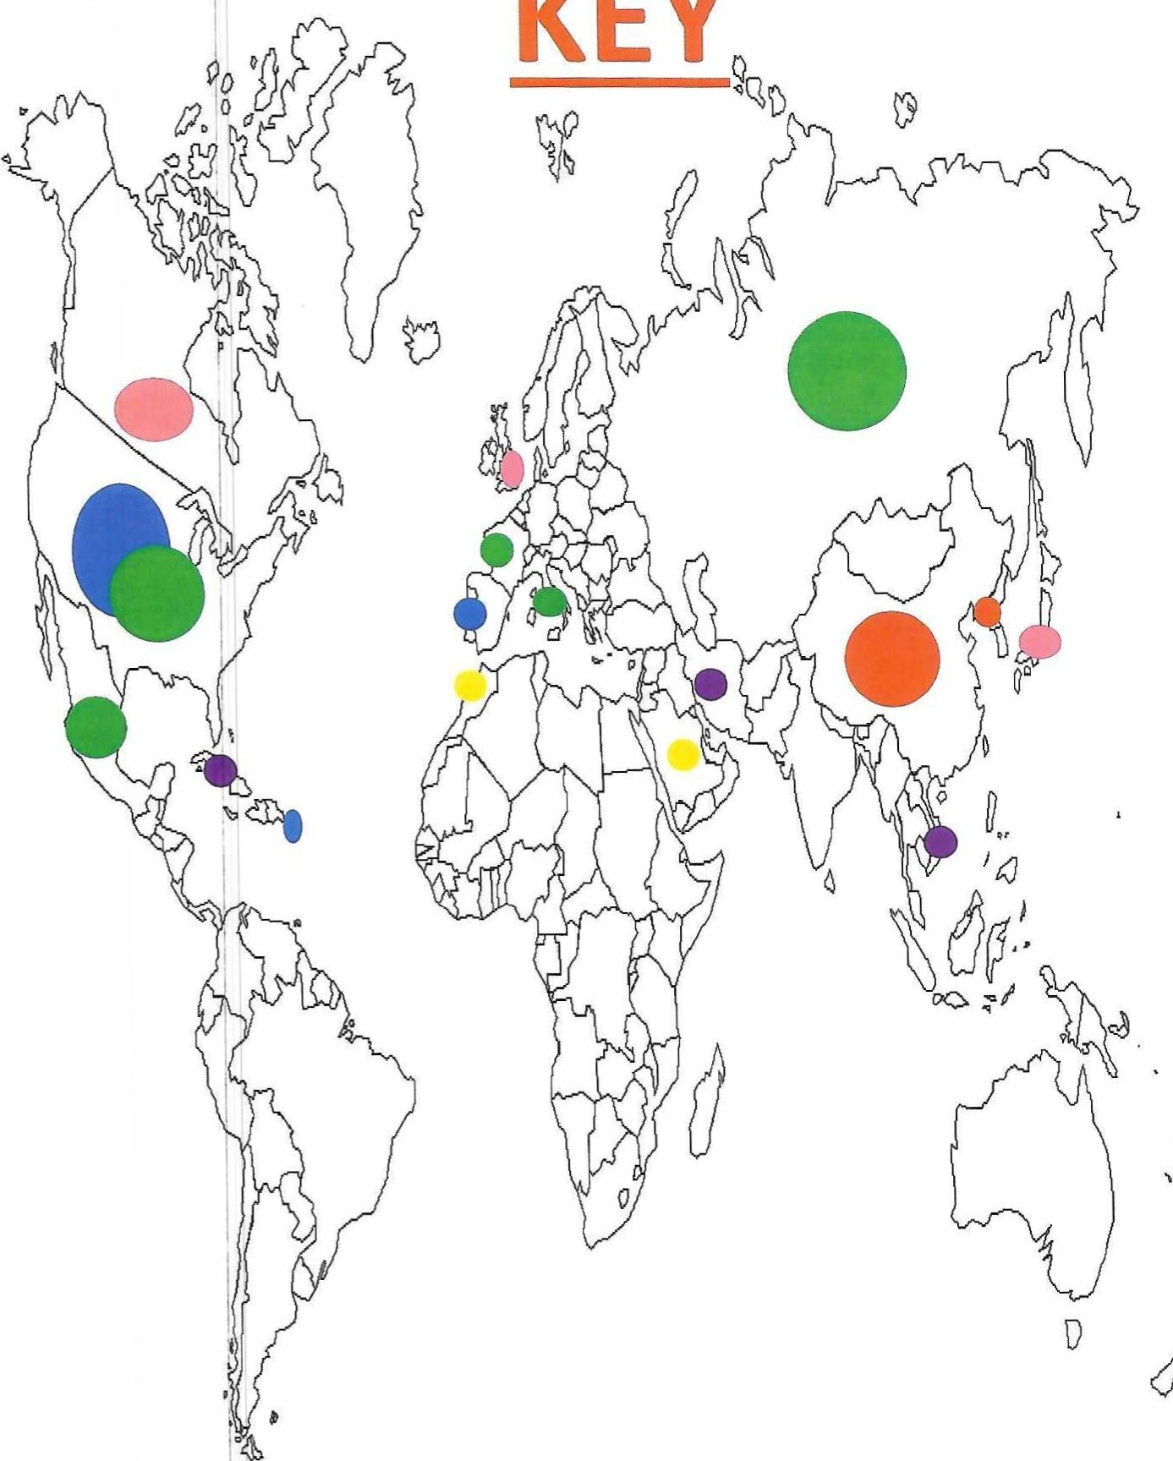
Color the Countries with the following Key; Constitutional Monarchy
KEY
Republic: Democracy Absolute Monarcy Totalitarianism

