From Ideas to Law

Laws are another word for legal rules. Schools, countries, states, and cities have laws to protect people. Elected officials make the laws. Laws take a long time because it has to be approved by many people.
Complete the Maze of Making a law.
Start

: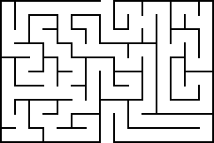

Think of a new “law” for our community.

