Station 2: What is authority?
The helper or teacher will read aloud the following points.

- What are some benefits of authority?
When we use authority, good things can happen. We call them benefits. A benefit is something good. We can use authority to solve problems.

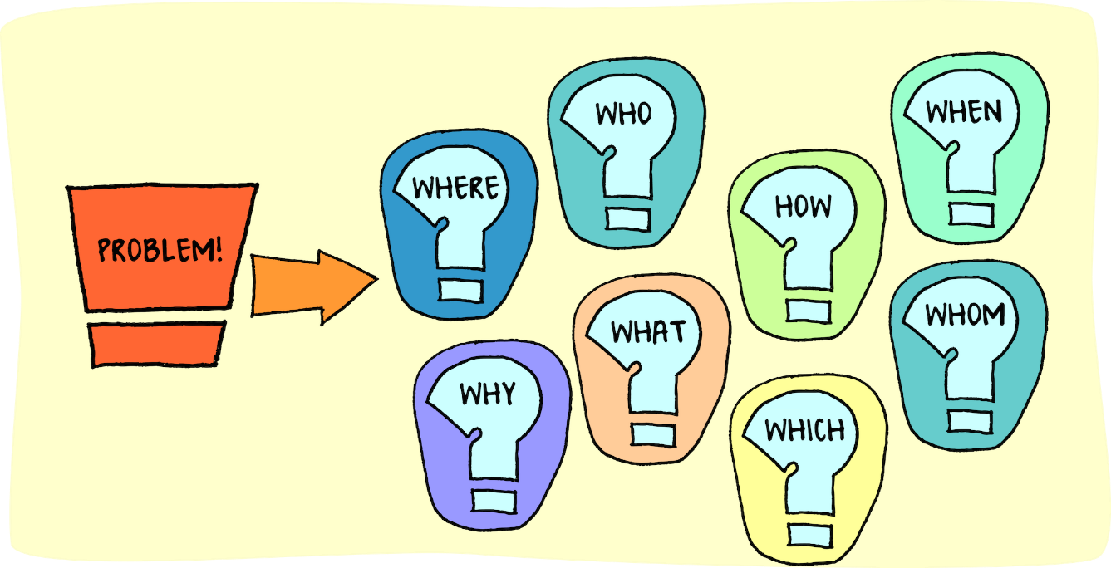

- Authority can help to keep us safe.
A rule at the swimming pool is “no running.” This rule helps to keep us from falling and getting hurt. The lifeguard is the authority to watch that no one runs.



3.Authority can help us share things in a fair way.

4.Authority can help us protect property.
Your parents might say, “Do not write in this book” to protect the book from damage.



5.Authority can prevent arguments.
When you play a game a referee makes sure players follow the rules so that one person who is not a player decides is a rule is broken.



6.Authority can keep order.

Libraries have rules about using books so that people can find the books they want.

