Worksheet on Mural: The theme will be civic representation or democracy

- Secure a building in Marietta for painting in good weather.
Brainstorm places:

Find out the owner:

Ask the owner with teacher’s permission and contact information.

- Secure an artist to design what you would like as a class

Brainstorm local artist and contact information

- Discuss and come up with your mural. Have someone do a rough sketch for approval.

- Invite your artist in to present their mural design for student approval

- 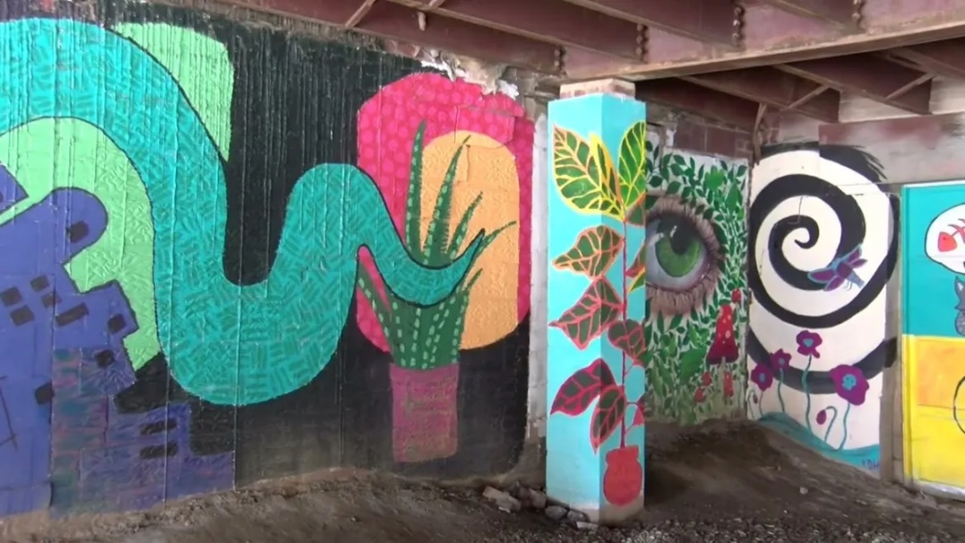

- Arrange (like a field trip) to paint the mural for a few days.

