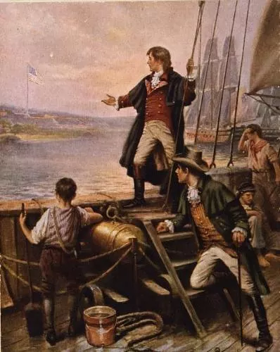
Teacher reads aloud as students follow:
Francis Scott Key stood on the deck of an American ship on September 14, 1814 and watched the raising of Fort McHenry’s large American flag over the ramparts or the wall around the fort. He had gone through Britain’s twenty-five-hour attack on the Fort, and for him, the raising of the American flag was a triumphant of bravery and strength. The American Flag inspired Key to write about what he had seen in a poem. The words spread like wildfire throughout the young nation. It became “The Star Spangled Banner” and was soon a popular patriotic song. In 1931, Key’s song was adopted as the national anthem of the United States.

