Amendment | Read the amendment  what are some key words. | Summarize the amendment in your own words. P.64
First Amendment
1791
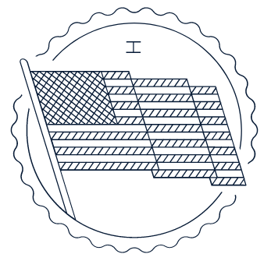
Second Amendment
1791
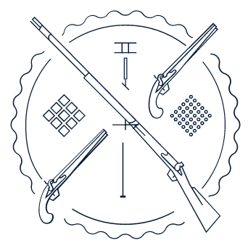
Third Amendment
1791
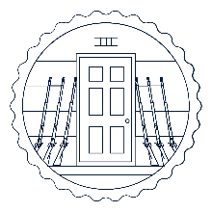
Fourth Amendment  1791  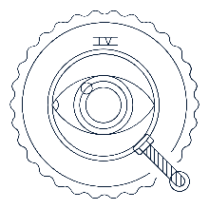 |  | p.65
Fifth Amendment
1791

Sixth Amendment
1791

Seventh Amendment
1791
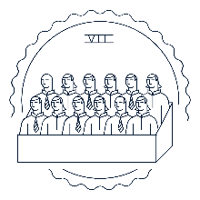
Eighth Amendment  1791   |  | p. 66
Ninth Amendment
1791
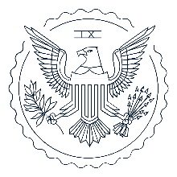
10th Amendment
1791

11th Amendment
1795
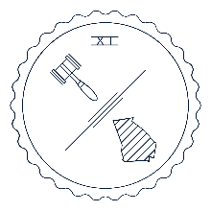
12th Amendment  1804  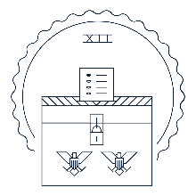 |  | p.67

Reconstruction era amendments: 1865 – 1870 (There was a 60+ year gap between the Founding and Reconstruction eras.)
Gave us three transformational amendments that many scholars argue represent our nation’s “Second Founding.”

Amendment | Read the amendment  what are some key words. | Summarize the amendment in your own words.
12th Amendment
1804
14th Amendment
1868
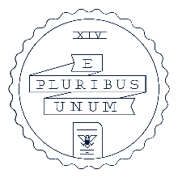
15th Amendment  1870   |  | p.68

The Progressive era: 1913 – 1920 (There was a 40+ year gap between the Reconstruction and Progressive eras.)
Gave us the 16th–19th Amendments.

Amendment | Read the amendment  what are some key words. | Summarize the amendment in your own words.
16th Amendment
1913
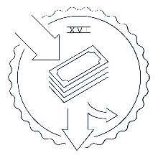
17th Amendment
1913
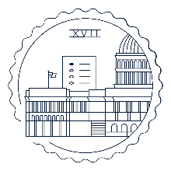
18th Amendment  1919  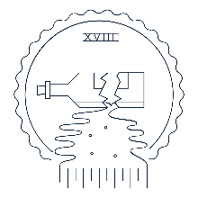 |  | p.69
19th Amendment
1920
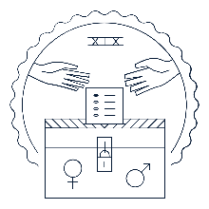
Modern era: 1933 – 1992 (It’s been over 30 years since the last amendment!)
Added the remaining eight amendments, little by little, between 1933 and 1992.

Amendment | Read the amendment  what are some key words. . | Summarize the amendment in your own words.
20th Amendment
1933

21st Amendment  1933  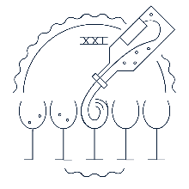 |  | p.70
22nd Amendment
1951
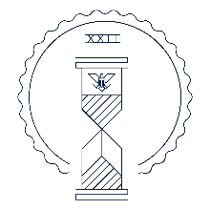
23rd Amendment
1961

24th Amendment  1964  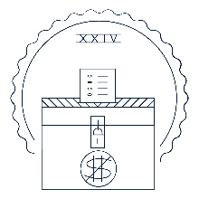 |  | p.71
25th Amendment
1967

26th Amendment
1971
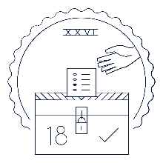
27th Amendment
1992
